**Milestone 1: NetCat**

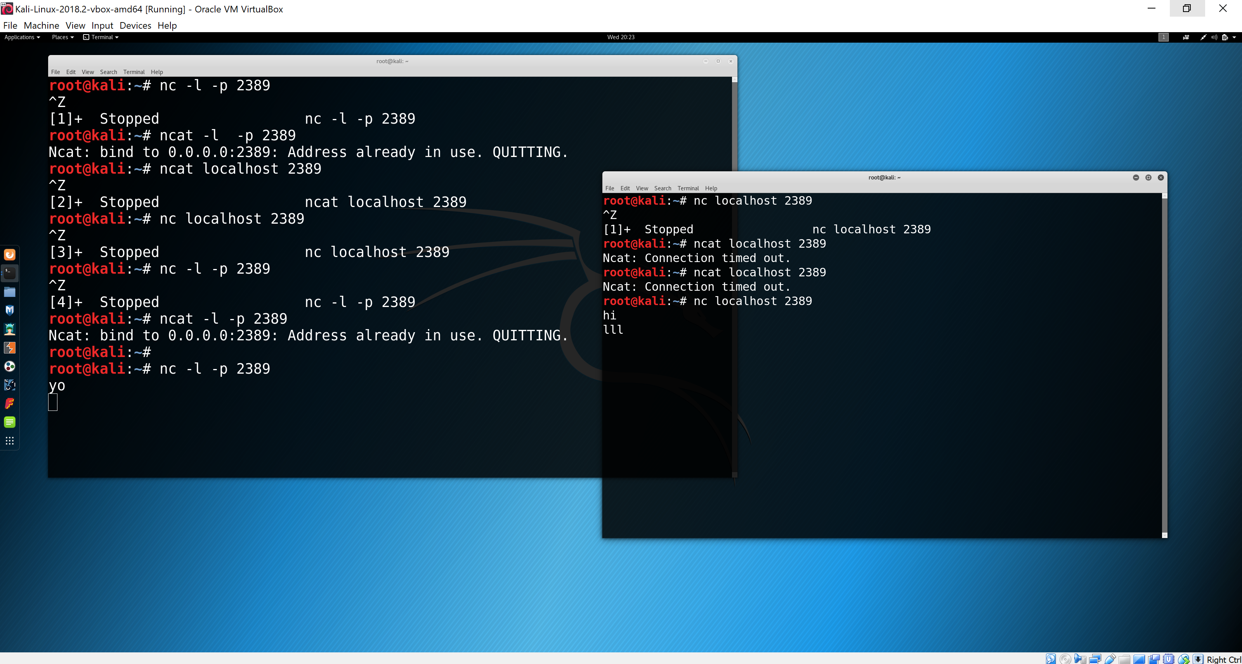

I entered the correct commands, but for some reason the connection wasn’t working. So, I was unable to complete this part of the lab. I tried to troubleshoot it ,but still couldn’t get it to work.

**NMAP**

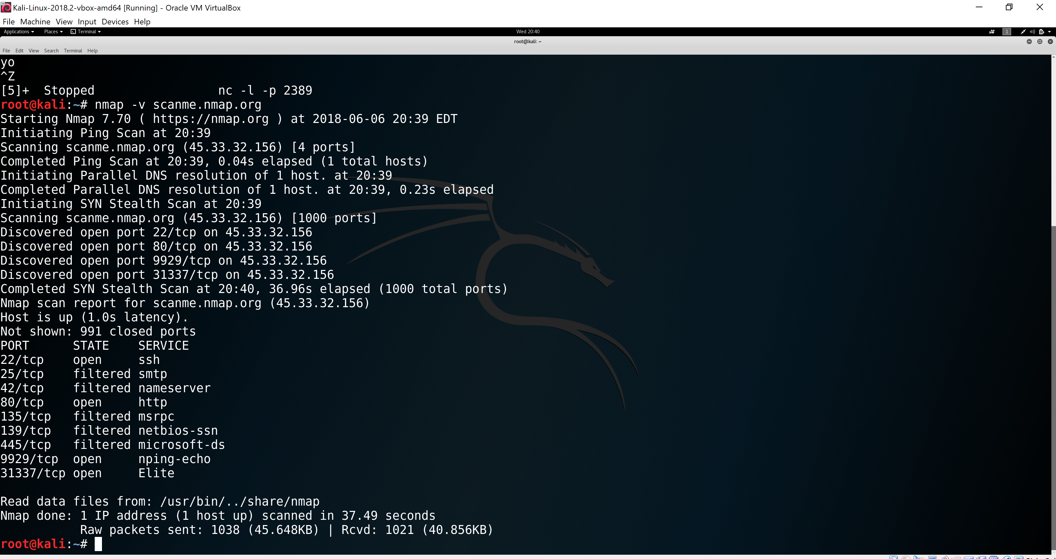

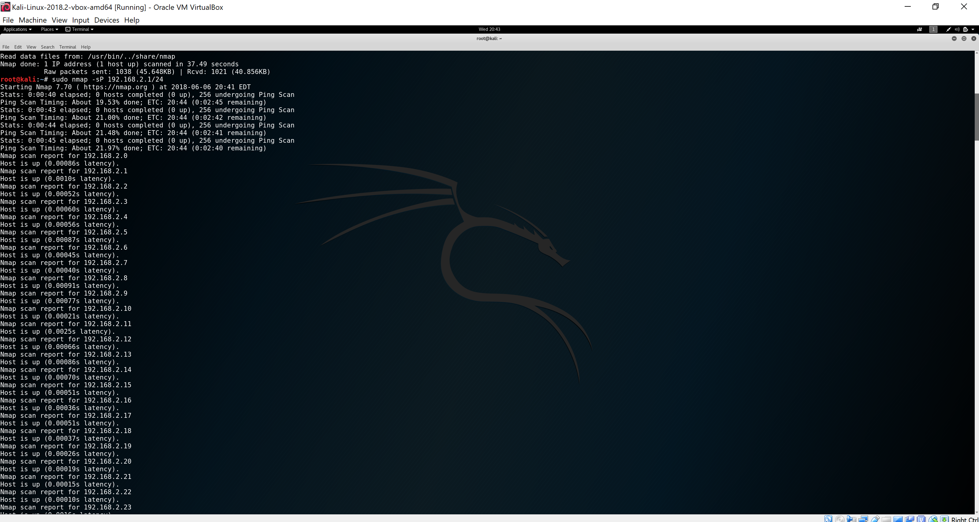

**Milestone 2: TCPDUMP**

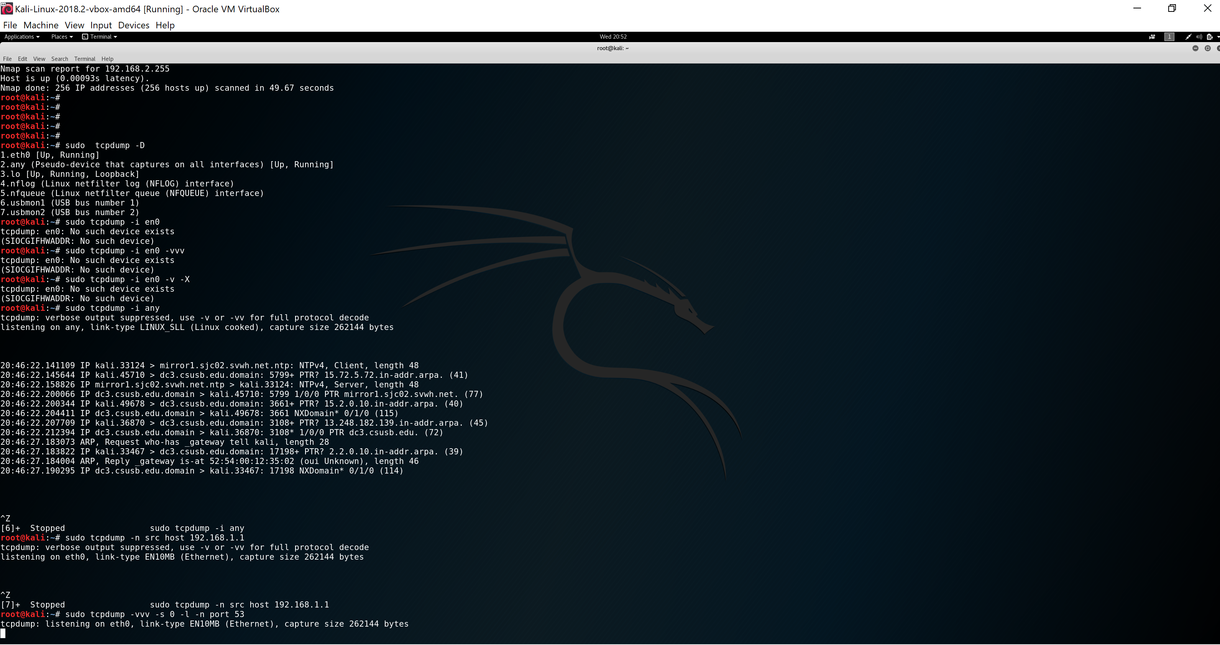

**Milestone 3: WIRESHARK**

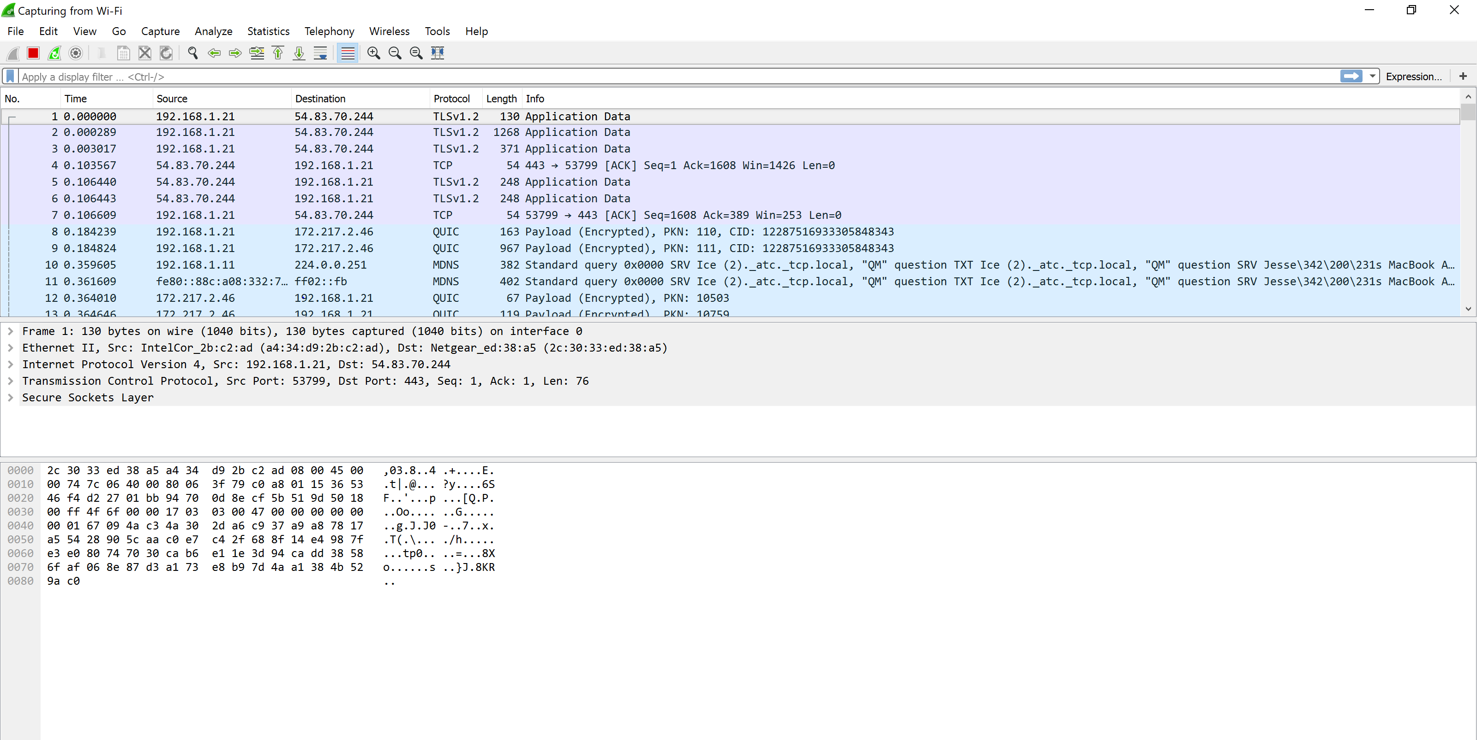

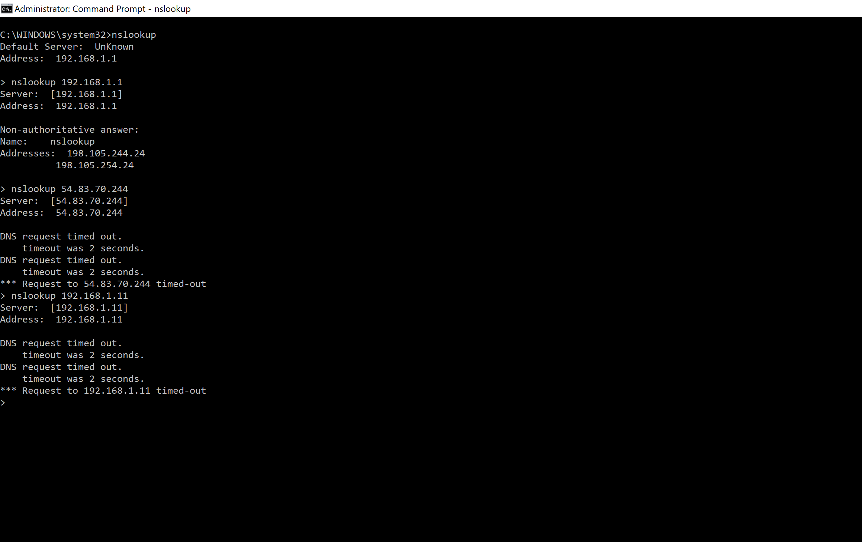

**Milestone 4**

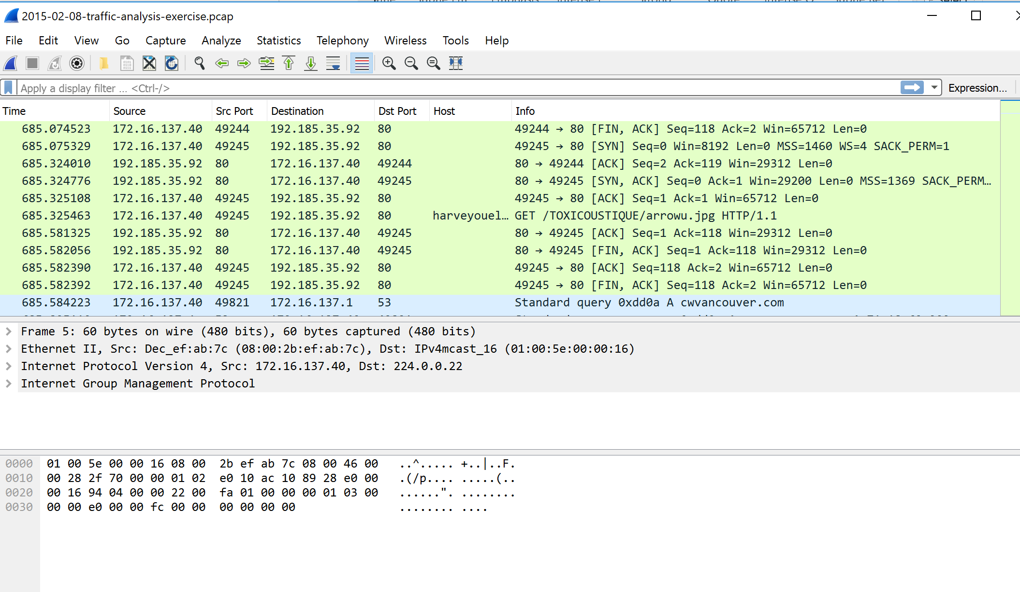

**Milestone 5**

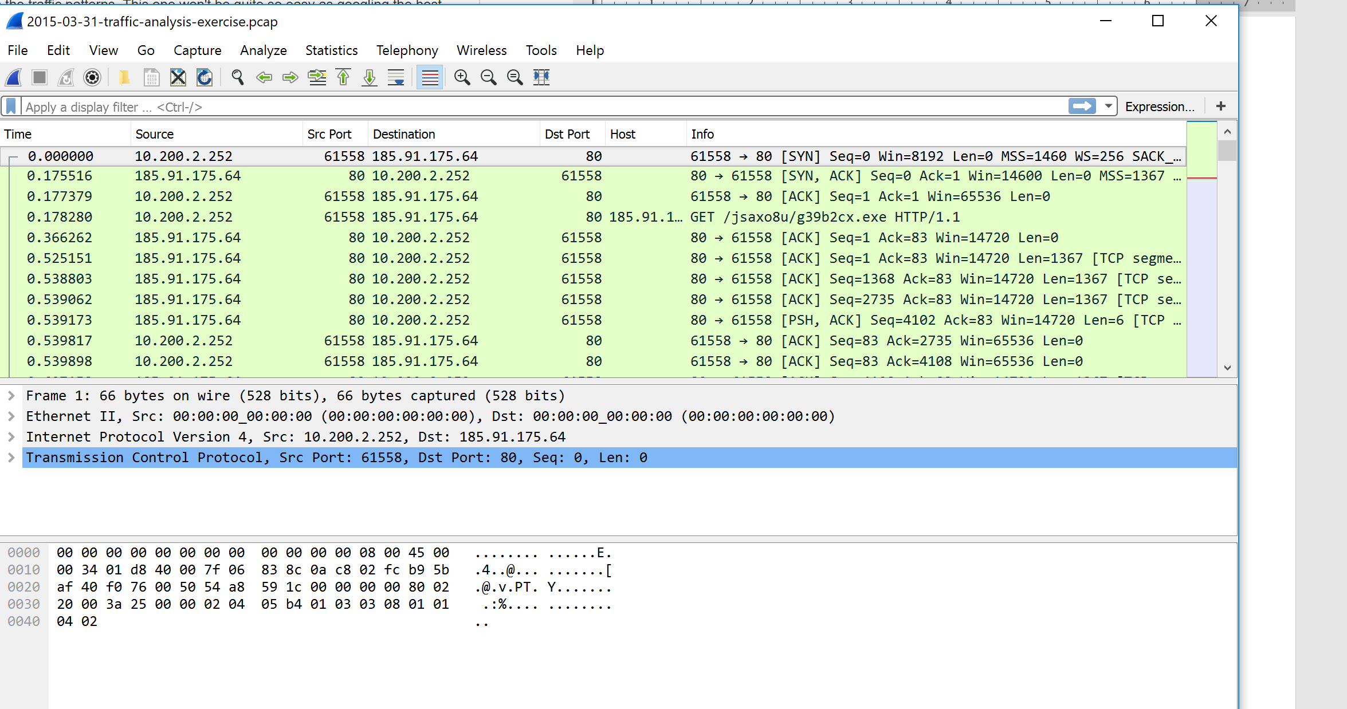

**Milestone 6**

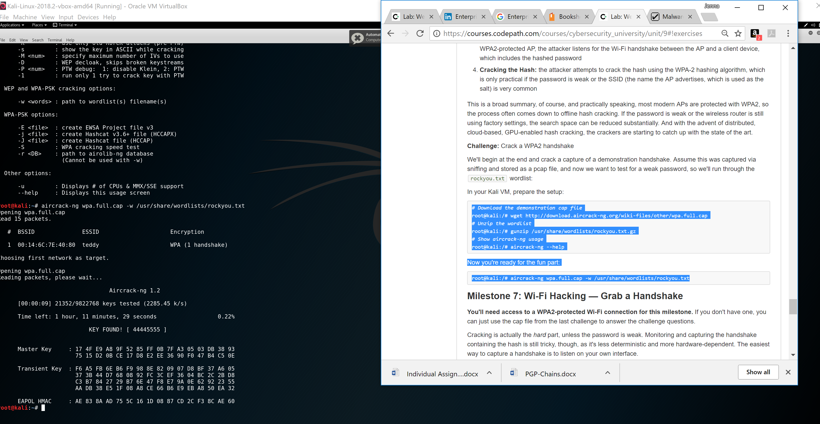

**Milestone 7**

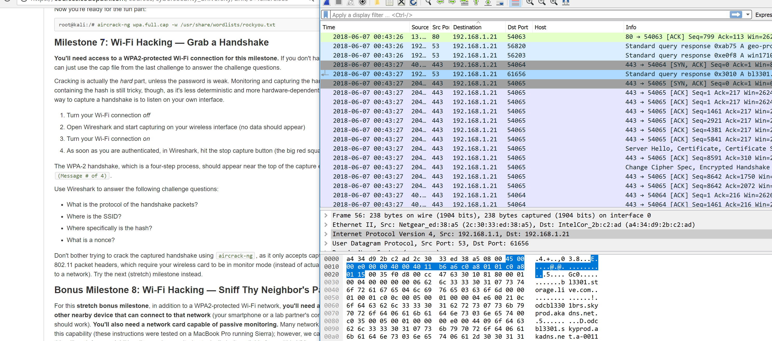

**Milestone 8**

